
INTERNSHIP COMPLETION CERTIFICATE
Date: - 30-06-2020

This is to certify that GREESHMA REDDY, student of TKR COLLEGE OF ENGINEERING AND TECHNOLOGY, has successfully completed her internship with SIMPLE NOTES ONLINE during the period 22-05-2020 TO 22-06-2020 As a content writer.
During the period, she handled all the works we assigned successfully.
During the course of internship, GREESHMA REDDY has shown great amount of responsibility, sincerity and a genuine willingness to learn and zeal to take on new assignments & challenges. In particular, her coordination skills and communication skills are par excellence and her attention to details is impressive.

We wish her all the very best for her future.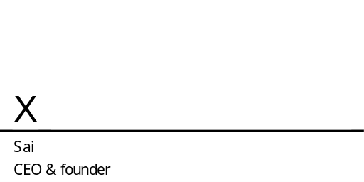

With regards,
J. SAI KISHORE
FOUNDER & CEO OF SIMPLE NOTES ONLINE

